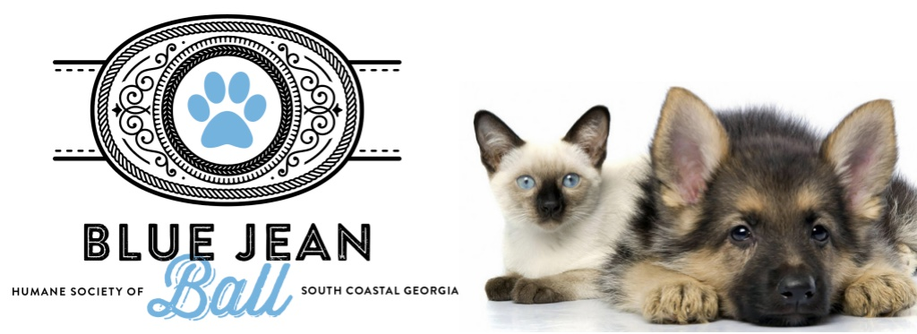
2019 Blue Jean Ball Sponsorship Commitment Form

Organization Name:
As it should appear on all marketing, advertising & program materials

Organization Contact:

Contact Email: Contact Phone:

Contact Address:

Sponsorship Level: Sponsorship Amount:

Additional Information: Please email your logo in either eps or jps format (300 dpi or higher) to connie@hsscg.org
Payment by Credit Card
Amount to be charged: $ Name on card: Card Type: Visa MC AmEx Card Number: EXP Date:
CVV# Billing Zip Code: Card Holder Signature:
Payment by Check
Please send completed form and check (Payable to HSSCG) to:
4627 US HWY 17 N, Brunswick, GA 31525. Please write Blue Jean Ball in the memo field.

Please include the names of attendees:

Ticket 1: Ticket 2:

Ticket 3: Ticket 4:

Ticket 5: Ticket 6:

Ticket 7: Ticket 8:

Name & Title
Please Print
Date:______________
Signature:
Humane Society of South Coastal Georgia is a Tax Exempt Organization…….501(c)3 EIN: 58-6073265
In the unlikely event the Blue Jean Ball has to be cancelled due to inclement weather, we will view your ticket purchase as a donation and the proceeds will go to the animals in our care. No refunds or credits will be given.

