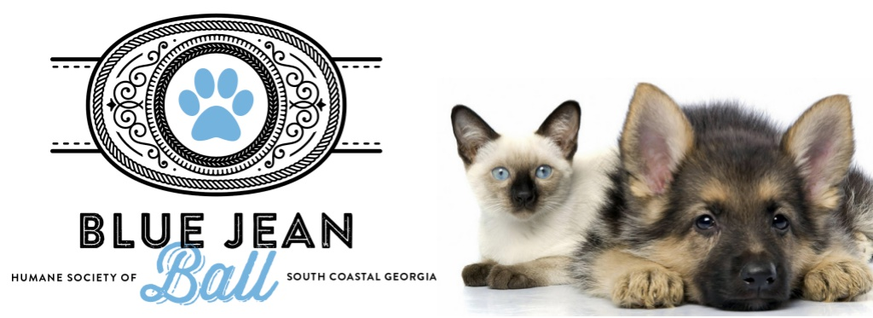

2019 Blue Jean Ball Sponsorships

The Blue Jean Ball will bring together people who are passionate about supporting the homeless animals in our community.

Sponsorship Levels:

Sponsorship materials must be received no later than October 1st

 | Bootcut  $5000 | Stonewash  $3000 | Faded  $1000 | Flare  $500
Inclusion of sponsor name and logo in promotional & advertising materials.
Reserved table seating
Private lounge
Tickets | 8 | 8 | 4 | 2

Individual Tickets: $160

Humane Society of South Coastal Georgia is a Tax Exempt Organization… 501(c)3 EIN: 58-6073265

In the unlikely event the Blue Jean Ball has to be cancelled due to inclement weather, we will view your ticket purchase as a donation and the proceeds will go to the animals in our care. No refunds or credits will be given.

